Attrition rate prediction
- ATTRITION RATE
No 1233
Yes 237
Name: count, dtype: int64
attrition_rate = data['Attrition'].mean() * 100
print("Attrition Rate:", attrition_rate)
Attrition Rate: 16.122448979591837

- Department wise attrition
dept_attrition = data.groupby('Department')['Attrition'].mean() * 100
print(dept_attrition)
Department
Human Resources 19.047619
Research & Development 13.839750
Sales 20.627803
Name: Attrition, dtype: float64
plt.figure()
sns.barplot(x=dept_attrition.index, y=dept_attrition.values)
plt.xticks(rotation=45)
plt.title("Attrition Rate by Department")
plt.show()
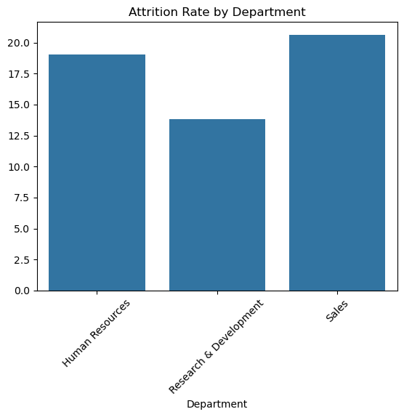
- OverTime v/s Attrition
No 13.836478
Yes 37.500000
Name: Attrition, dtype: float64
sales_data.groupby('JobSatisfaction')['Attrition'].mean() * 100
- JobSatisfaction v/s Attrition
High 21.259843
Low 26.744186
Medium 23.255814
Very High 14.965986
Name: Attrition, dtype: float64
plt.figure()
sns.boxplot(x=sales_data['Attrition'], y=sales_data['MonthlyIncome'])
plt.title("Salary vs Attrition (Sales)")
plt.show()
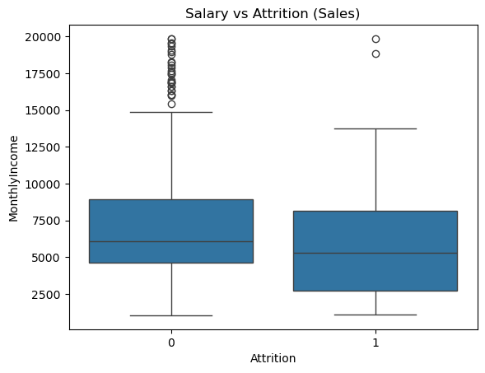

- Attrition v/s monthly income
0 7232.240113
1 5908.456522
Name: MonthlyIncome, dtype: float64
sales_data.groupby('WorkLifeBalance')['Attrition'].mean() * 100
- WorkLifeBalance v/s attrition
Bad 37.500000
Best 23.076923
Better 18.115942
Good 23.529412
Name: Attrition, dtype: float64
- TRAINED 80% AND TESTED 20%
1470, 35)
['Yes' 'No']
Missing values in Attrition: 0
data['Attrition'] = data['Attrition'].replace({'Yes': 1, 'No': 0})
Model Accuracy: 0.8469387755102041

Predicted Future Attrition (%):
Department
Human Resources | 17.625818
Sales | 17.028689
Research & Development | 16.469842
Name: Attrition_Prob, dtype: float64
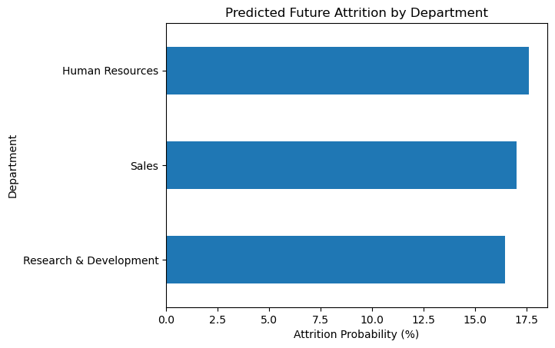
- Interpretation:
The predictive model shows that the Human Resources department has the highest average attrition probability (17.62%), followed closely by Sales (17.03%), while Research & Development (16.47%) has the lowest predicted attrition risk.
This indicates that HR employees are slightly more likely to leave in the future on average, although the difference across departments is relatively small.

Department-wise Risk Level Distribution
Number of High Risk Employees: per department
Risk_Level | High | Low | Medium
Department
Human Resources | 1 | 53 | 9
Research & Development | 25 | 819 | 117
Sales | 17 | 371 | 58

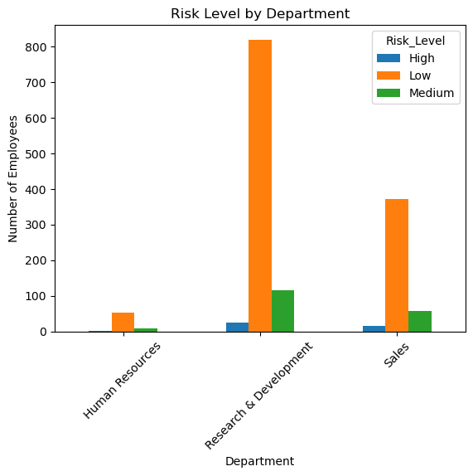
Interpretation (VERY IMPORTANT)
Although the Research & Development department has the highest number of high-risk employees in absolute terms, this is primarily because it has a significantly larger workforce.
When analyzing proportionally, the Sales department shows a higher concentration of high-risk employees, indicating a more critical attrition problem in Sales compared to other departments.

High-Risk Employee Concentration by Department
High Risk % by Department:
Department
Sales | 14.349776
Human Resources | 7.936508
Research & Development | 5.619147
Name: High, dtype: float64
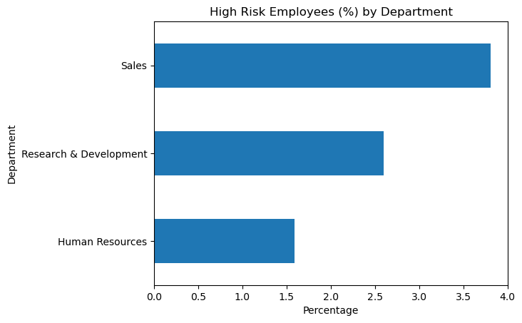

Interpretation:
The Sales department has the highest proportion of high-risk employees, followed by R&D, while HR shows the lowest proportion.
This suggests that attrition risk is more concentrated and severe in Sales, even though HR has a slightly higher average predicted attrition probability.

Employee Attrition Prediction using Machine Learning
1. Introduction
Employee attrition is a critical issue for organizations as it affects productivity, cost, and workforce stability. The objective of this project is to analyze employee data, identify key factors influencing attrition, and build a predictive model to estimate future attrition risk across departments.

2. Dataset Overview
The dataset consists of 1470 employees and 35 features, including:
- Age
- Department
- Monthly Income
- Job Satisfaction
- Work-Life Balance
- Overtime
- Attrition (Yes/No)
The target variable Attrition indicates whether an employee has left the organization.

3. Overall Attrition Analysis
- Total Employees: 1470
- Employees Left: 237
- Employees Stayed: 1233
Overall Attrition Rate: 16.12%
Interpretation
The organization has a moderate attrition rate, indicating that approximately 1 in 6 employees leave the company.

4. Department-wise Attrition Analysis
- Sales → 20.63%
- Human Resources → 19.05%
- Research & Development → 13.84%
Interpretation
The Sales department has the highest attrition, followed by HR, while R&D shows relatively stable employee retention.

5. Key Factors Affecting Attrition
5.1 Overtime vs Attrition
- No Overtime → 13.83%
- Overtime → 37.50%
Insight: Employees working overtime are significantly more likely to leave.

5.2 Job Satisfaction vs Attrition
- Low → 26.74%
- Medium → 23.26%
- High → 21.26%
- Very High → 14.97%
Insight: Lower job satisfaction leads to higher attrition.

5.3 Salary vs Attrition
- Stayed Employees → ₹7232 (avg)
- Left Employees → ₹5908 (avg)
Insight: Employees with lower salaries are more likely to leave.

5.4 Work-Life Balance vs Attrition
- Bad → 37.50%
- Better → 18.11%
- Good → 23.52%
Insight: Poor work-life balance significantly increases attrition.

6. Machine Learning Model
- Model Used: Logistic Regression
- Training Data: 80%
- Testing Data: 20%
- Model Accuracy: 84.69%
Interpretation
The model performs well and can reliably predict employee attrition.

7. Predicted Future Attrition by Department
- Human Resources → 17.62%
- Sales → 17.03%
- Research & Development → 16.47%
Interpretation
The predictive model indicates that HR has slightly higher average future attrition risk, although differences between departments are minimal.

8. Risk Segmentation Analysis
Employees were classified into:
- High Risk
- Medium Risk
- Low Risk
High Risk Employee Distribution
Department | High | Medium | Low
HR | 1 | 9 | 53
R&D | 25 | 117 | 819
Sales | 17 | 58 | 371

Interpretation
Although R&D has the highest number of high-risk employees, this is due to its larger workforce.

9. High-Risk Employee Concentration (%)
- Sales → 14.35%
- HR → 7.94%
- R&D → 5.62%
Interpretation
The Sales department has the highest proportion of high-risk employees, indicating a more critical and immediate attrition problem compared to other departments.

10. Final Conclusion
This project provides both descriptive and predictive insights into employee attrition:
- The overall attrition rate is 16.12%, with Sales being the most affected department.
- Key drivers of attrition include overtime, low salary, poor job satisfaction, and weak work-life balance.
- The predictive model achieved 84.69% accuracy, indicating strong performance.
- While HR shows slightly higher average predicted attrition,
the Sales department has the highest concentration of high-risk employees.
Final Insight
The analysis suggests that Sales requires immediate retention strategies, while HR may experience gradual attrition over time. R&D remains relatively stable.

11. Business Recommendations
- Reduce overtime workload in Sales
- Improve salary structure for low-income employees
- Enhance employee engagement programs
- Focus on improving work-life balance
- Monitor high-risk employees proactively

12. Conclusion
This project demonstrates how data analytics and machine learning can help HR teams identify attrition risks early and make data-driven decisions to improve employee retention.

